Day 2 20-October-2026

Activity 1.2 (Problem 4) POE
1.2.1 IPO CHART
Input | Processing | Output
Input the First number. (X) | Check whether First number (X) and Second number (Y) are positive whole numbers greater than zero. | If either number is zero or negative, display an error message.
Input the second number. (Y) | If the inputs are invalid, stop the calculation. | Display: “Please enter positive whole numbers.”
 | If both inputs are valid, compare First number (X) and Second number (Y). | If the inputs are valid, continue calculating the HCF.
 | Assign the smaller number to Factor. | Display the Highest Common Factor.
 | Check whether both numbers divide exactly by Factor.
 | If either number does not divide exactly, subtract 1 from Factor.
 | Repeat the division test until both numbers divide exactly.

1.2.2 FLOWCHART DIAGRAM

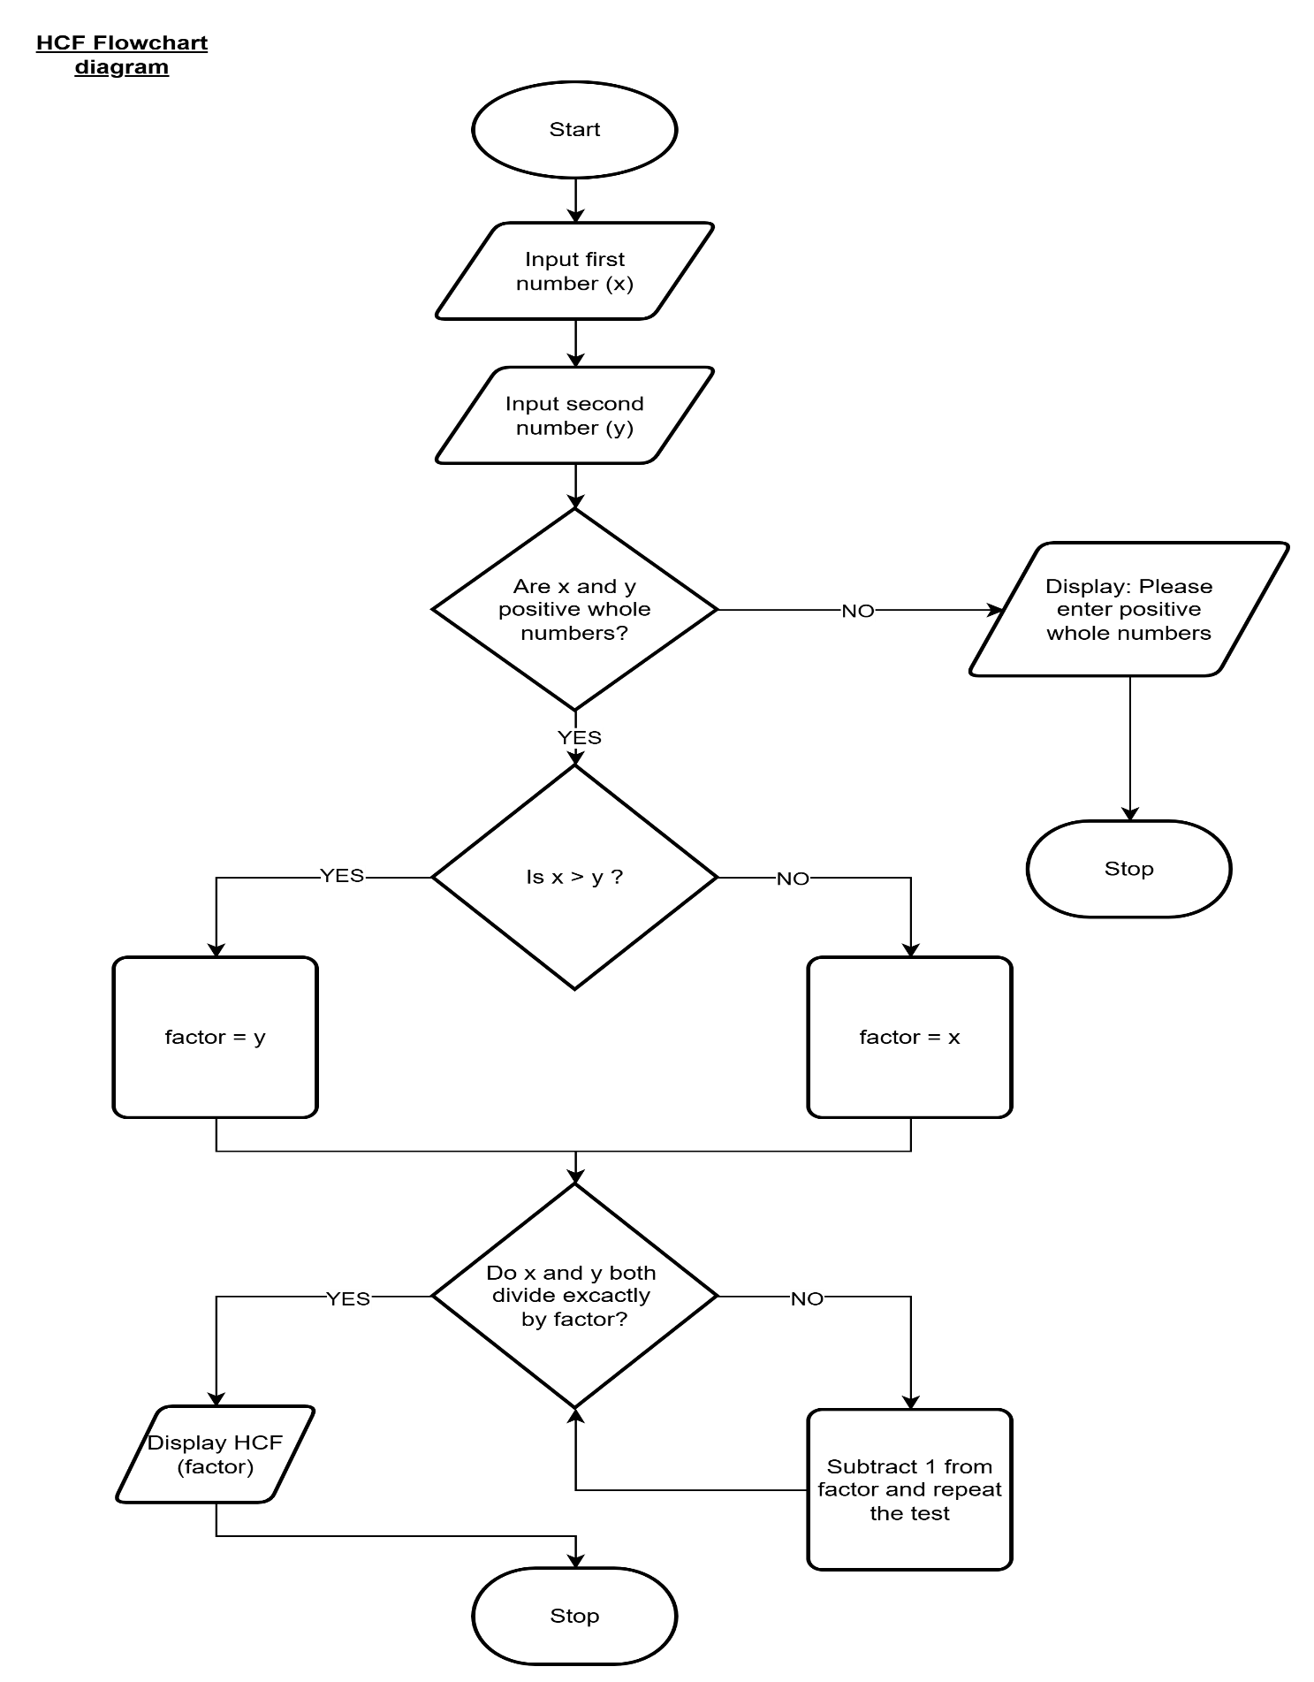

1.2.3 Trace table
Test case | First number (x) | Second number (y) | Expected result
#1 | 15 | 21 | 3
#2 | 9 | 17 | 1 (no common factor except 1)
#3 | 8 | 8 | 8
#4 | 0 | -5 | Enter positive whole numbers

